VENANGO TECHNOLOGY CENTER
JOINT COMMITTEE
1 Vo-Tech Drive
Oil City, Pennsylvania 16301

MINUTES

August 3, 2020

The regular meeting of the Venango Technology Center Joint Committee was held this evening in the Conference Room of the Venango Technology Center, 1 Vo-Tech Drive, Oil City, PA 16301. Mrs. Neely called the meeting to order at seven o’clock (7:00) p.m.

Mrs. Neely asked the members to pause for a moment of silence.

Mrs. Neely asked the members to stand for the pledge of allegiance.

Roll Call: Present: Robert Blauser, Todd Carson, James Come, Mark Marterella, James
Disque, Jeff Thomas (via phone), Misty Nalepa (via phone), Shari Neely

Absent: Troy Johnston, Don Judy

Also Present: Mr. Mario Fontanazza, Dr. Lynda Weller

Mrs. Neely stated the Joint Committee members had received copies of the Minutes of the June 1, 2020 meeting in the mail. She asked if there were any additions, corrections or deletions.

Mr. Carson, seconded by Mr. Marterella, moved to approve the Minutes of the June 1, 2020 meeting as submitted.

Roll Call: Ayes: Robert Blauser, Todd Carson, James Come, Mark Marterella, James
Disque, Jeff Thomas (via phone), Misty Nalepa (via phone), Shari Neely

Nayes: None, motion carried.

The Treasurer and Secretary’s Report as of 6/30/20 and 8/3/20 were submitted for information.

Mr. Carson, seconded by Mr. Marterella, moved to accept the Treasurer and Secretary’s Report as of 6/30/20 and 8/3/20 as submitted.

The motion was unanimously approved.

A list of bills from 6/2/20 – 6/30/20 in the amount of $751,556.97 and a list of bills from 7/1/20 – 8/3/20 in the amount of $685,652.62 was presented for approval.

Mr. Carson, seconded by Mr. Marterella, moved to approve the list of bills as presented.

Roll Call: Ayes: Robert Blauser, Todd Carson, James Come, Mark Marterella, James
Disque, Jeff Thomas (via phone), Misty Nalepa (via phone), Shari Neely

Nayes: None, motion carried.

Under Communications, Mr. Fontanazza discussed the Professional Advisory Committee. He also discussed the Calendar of Events for the month of July and the Monthly Enrollment Report as of 8/3/20 were submitted.

Mrs. Neely requested approval of the action items as presented. Item 8. a) i.- xiii. excluding v. in one motion.

Mr. Carson, seconded by Mr. Marterella, moved to approve action items i.- xiii. excluding v. as follows:

- Appoint Mario Fontanazza as the School Safety and Security Coordinator.
- Approve Budget Transfers for 2019-2020.
- Approval of the 2020-2021 Bus Drivers.
- Approve List of courses for the 2020-2021 school year.
- Approve Occupational Advisory Committee members for 2019-2020.
- Approve George Svolos as Administrative substitute at a rate of $150.00 per day.
- Approve Facility use contract with Clarion University for Adult Emergency Medical
    - Technician (EMT) course beginning in September 2020.
- Approve Student and Employee Handbooks for 2020-2021.
- Approve Practical Nursing substitute instructor list for 2020-2021.
- Approve textbook and workbook for Heavy Equipment Repair Technology; Heavy Duty Truck
Systems, 7th edition, author – Sean Bennett published by Cengage
- Approve Curve Dental instruction software.
- Approve Venango Technology Center COVID-19 plan.
- Approve Bob Moore and Carol Miller to attend the Pennsylvania Apprenticeship Summit in
Hershey on October 30-31, 2020 at a cost not to exceed $1,000.00 – Funding Local.

Roll Call: Ayes: Robert Blauser, Todd Carson, James Come, Mark Marterella, James
Disque, Jeff Thomas (via phone), Misty Nalepa (via phone), Shari Neely

Nayes: None, motion carried.

Mr. Fontanazza reviewed his Issues/Activities for July and August 2020

Upon motion by Mr. Carson, seconded by Mr. Marterella, the meeting adjourned at seven thirteen (7:13) p.m.

Recorded by
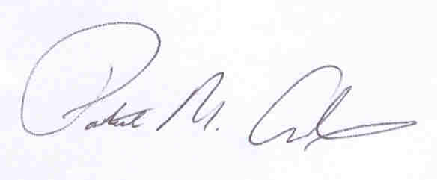
Patrick M. Adams
Secretary, Joint Committee

